**Assignment No. : _**

**Title:** To control remote machine

**Aim:** Installation and setup to control the remote machine

**Objective:** To study how to access remote machine

**Theory:** Refers to a [program](http://www.webopedia.com/TERM/P/program.htm)'s or device's ability to control a [computer system](http://www.webopedia.com/TERM/C/computer_system.htm) from a [remote](http://www.webopedia.com/TERM/R/remote.htm) location. Remote-control programs for [PCs](http://www.webopedia.com/TERM/P/PC.htm) enable you to access [data](http://www.webopedia.com/TERM/D/data.htm) [stored](http://www.webopedia.com/TERM/S/store.htm) on your home [system](http://www.webopedia.com/TERM/S/system.htm) even when you are traveling.

Remote control is different from [remote access](http://www.webopedia.com/TERM/R/remote_access.htm). In remote control, only keystrokes and screen updates are transmitted between the two machines as all processing originates in the remote-control device. In a remote access setup, the user is [logged onto](http://www.webopedia.com/TERM/L/log_on.htm) the network, using the phone line as an extension to the network. Thus, all traffic has to flow over a low-speed telephone line.

Epoptes (Greek word for overseer) is an [open source](http://gplv3.fsf.org/) computer lab management and monitoring tool. It allows for screen broadcasting and monitoring, remote command execution, message sending, imposing restrictions like screen locking or sound muting the clients and much more! It's a partial rewrite of an older application called [sch-scripts](http://wiki.ubuntu-gr.org/sch-scripts/screenshots).

It can be installed in [Ubuntu](http://packages.ubuntu.com/epoptes), [Debian](http://packages.debian.org/epoptes) and [openSUSE](http://www.epoptes.org/news/opensusepackagesavailable) based labs that may contain any combination of the following: [LTSP](http://www.ltsp.org/) servers, [thin](https://help.ubuntu.com/community/UbuntuLTSP) and [fat](https://help.ubuntu.com/community/UbuntuLTSP/FatClients) clients, non LTSP servers, standalone workstations, [NX](http://en.wikipedia.org/wiki/NX_technology) or [XDMCP](https://wiki.ubuntu.com/xdmcp) clients etc. The following figure shows working of epoptes software.

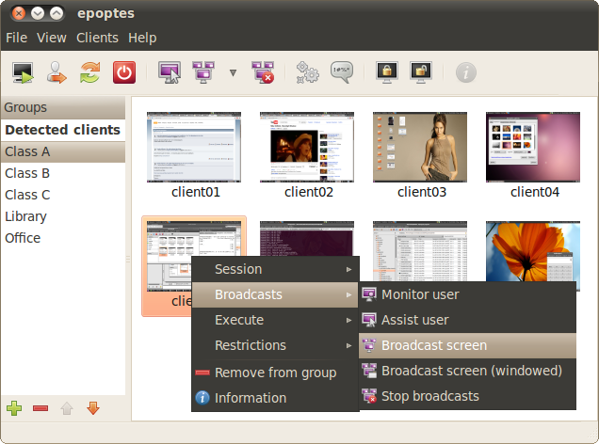

**Installations steps of Epoptes:** Epoptes consists of a server package called epoptes and a client package called epoptes-client. Install the server part on the PC where you'll be monitoring the clients from. If you want to use the GUI from a thin-client, install it on the LTSP server.

1. Execute the commands as root for server: apt-get install epoptes
2. After the installation you need to add some users to group "epoptes": gpasswd -a username epoptes
3. Users that are currently logged on need to logoff/logon for the group change to take effect
4. Execute the commands as root for client: apt-get install epoptes-client
5. Client package installation for standalone clients- execute the commands as root: apt-get install epoptes-client
6. Then you need to tell epoptes-client to which server it should connect.
7. The client package settings are stored in /etc/default/epoptes-client. A useful variable in that file is SERVER, which is the DNS name or IP address of the server that the clients will be connecting to.
8. Users that are currently logged on need to logoff/logon for the group change to take effect.

**Platform/ Languages used:**

**Conclusion:** Therefore, we have successfully set up, configure epoptes server and control it with multiple clients.

**FAQs:**

1. Enlist and compare different remote desktop software